

**JK Lakshmipat University**

*Institute of Engineering & Technology*

**LAB1 (ASSIGNMENT SET -1)**

*CS1134: Computer Organisation and Architecture*

**Submitted by**  
Name: Siddhi Nyati  
Roll No: 2022btech101

**Faculty Supervisor:**

Dr. Pranab Roy

Dr. Ajai Jain

Activity no: 1

1.3: 4-bit Adder Subtractor

**Question 4:** To design a VHDL model for a 4-bit adder-subtractor that can perform both addition and subtraction using 2's complement method, controlled by a single control bit.

**Theoretical Components:**

1. 4-bit Full Adder: Combines inputs to produce sum and carry outputs.
2. 2's Complement: Used for subtraction by inverting the bits and adding one.
3. Control Bit: Determines whether the operation is addition or subtraction.

**Theory:**

The 4-bit adder-subtractor circuit utilizes full adders to perform both operations based on the value of a control signal (let's denote it as Control). When Control is 0, the circuit performs addition; when Control is 1, it performs subtraction.

**Full Adder:**

A full adder takes three inputs: two significant bits and a carry input. It produces a sum output and a carry output. The Boolean expressions for the sum (S) and carry (C) are:

* Sum: S=A⊕B⊕Cin ​
* Carry: Cout=(A⋅B)+(Cin⋅(A⊕B))

**2's Complement:**

To subtract B from A, we convert B into its 2's complement:

1. Invert the bits of B.
2. Add 1 to the least significant bit (LSB).

This allows the adder to compute A+(−B)A + (-B)A+(−B).

**VHDL CODE OF THE ADDER & SUBTRACTOR**

----------------------------------------------------------------------------------

-- Company:

-- Engineer:

--

-- Create Date: 04:10:58 08/15/2024

-- Design Name:

-- Module Name: adder_subtractor - Structural

-- Project Name:

-- Target Devices:

-- Tool versions:

-- Description:

--

-- Dependencies:

--

-- Revision:

-- Revision 0.01 - File Created

-- Additional Comments:

--

----------------------------------------------------------------------------------

library IEEE;

use IEEE.STD_LOGIC_1164.ALL;

use IEEE.STD_LOGIC_ARITH.ALL;

use IEEE.STD_LOGIC_UNSIGNED.ALL;

entity Adder_Subtractor is

Port (

A : in STD_LOGIC_VECTOR(3 downto 0); -- 4-bit input A

B : in STD_LOGIC_VECTOR(3 downto 0); -- 4-bit input B

Control : in STD_LOGIC; -- Control signal (0: Add, 1: Subtract)

Sum : out STD_LOGIC_VECTOR(3 downto 0); -- 4-bit Sum output

Cout : out STD_LOGIC -- Carry output

);

end Adder_Subtractor;

architecture Behavioral of Adder_Subtractor is

signal B_comp : STD_LOGIC_VECTOR(3 downto 0); -- 2's complement of B

signal C : STD_LOGIC_VECTOR(4 downto 0); -- Carry bits for full adder

begin

-- Generate the 2's complement of B when Control is 1

B_comp <= not B when Control = '1' else B;

-- Add 1 to the LSB if subtracting

process(A, B_comp, Control)

begin

if Control = '1' then

C(0) <= '1'; -- Adding 1 for 2's complement

else

C(0) <= '0'; -- No carry for addition

end if;

for i in 0 to 3 loop

if i = 0 then

C(i + 1) <= (A(i) xor B_comp(i)) xor C(i);

Sum(i) <= C(i + 1);

else

C(i + 1) <= (A(i) xor B_comp(i)) xor C(i);

Sum(i) <= C(i + 1);

end if;

end loop;

Cout <= C(4); -- Final carry out

end process;

end Behavioral;

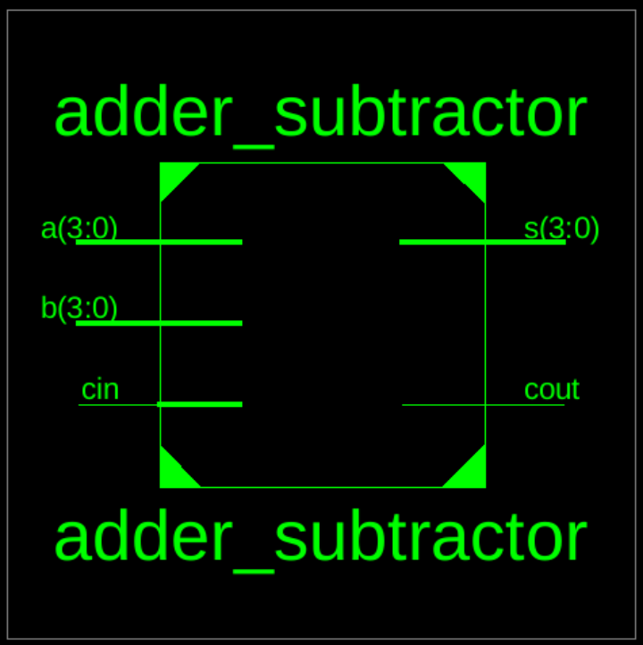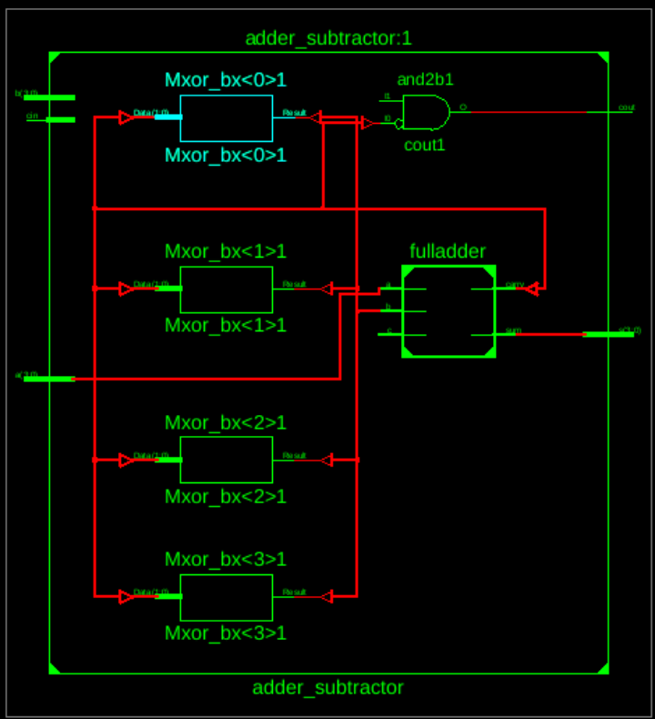

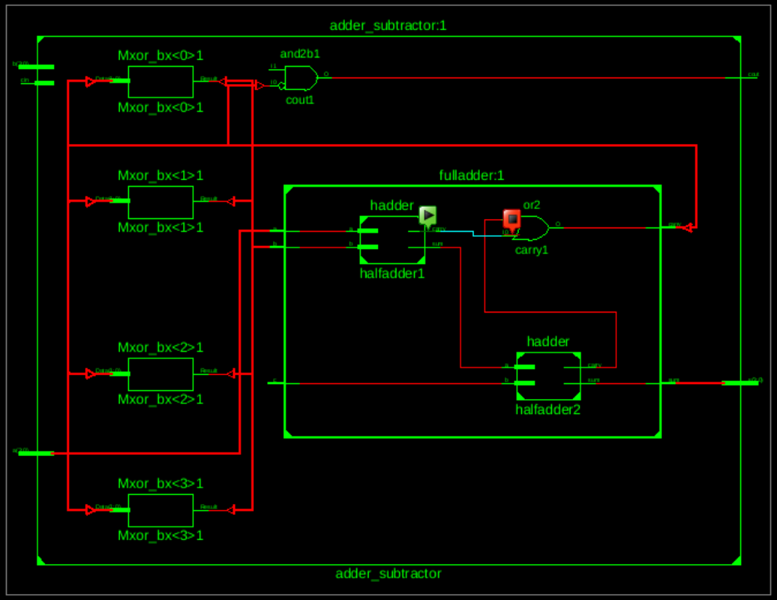

**TEST BENCH CODE OF THE ADDER SUBTRACTOR**

--------------------------------------------------------------------------------

-- Company:

-- Engineer:

-- Create Date: 04:47:13 08/15/2024

-- Design Name:

-- Module Name: /home/ise/Desktop/f1byh/sub_addtb.vhd

-- Project Name: f1byh

-- Target Device:

-- Tool versions:

-- Description:

-- VHDL Test Bench Created by ISE for module: adder_subtractor

--

-- Dependencies:

--

-- Revision:

-- Revision 0.01 - File Created

-- Additional Comments:

--

-- Notes:

-- This testbench has been automatically generated using types std_logic and

-- std_logic_vector for the ports of the unit under test. Xilinx recommends

-- that these types always be used for the top-level I/O of a design in order

-- to guarantee that the testbench will bind correctly to the post-implementation

-- simulation model.

--------------------------------------------------------------------------------

library IEEE;

use IEEE.STD_LOGIC_1164.ALL;

entity tb_adder_subtractor is

end tb_adder_subtractor;

architecture test of tb_adder_subtractor is

signal A, B: STD_LOGIC_VECTOR(3 downto 0);

signal SUB: STD_LOGIC;

signal SUM: STD_LOGIC_VECTOR(3 downto 0);

signal COUT: STD_LOGIC;

component four_bit_adder_subtractor

Port ( A : in STD_LOGIC_VECTOR(3 downto 0);

B : in STD_LOGIC_VECTOR(3 downto 0);

SUB : in STD_LOGIC;

SUM : out STD_LOGIC_VECTOR(3 downto 0);

COUT : out STD_LOGIC);

end component;

begin

UUT: four_bit_adder_subtractor port map (A, B, CIN);

process

begin

-- wait;

A <= NOT A AFTER f 100 NS;

B<=NOT B AFTER 200 NS:

CIN<=NOT CIN AFTER 300 NS:

end process;

end test;

